| Berkley: | ALFREDO FLOREZ | structural and biophysical characterization of DNA-protein complexes using cryoEM

| Cambridge: | Oliver Powell | quantum photonic devices. From hexagonal boron nitride

# Research Proposal: Incorporating Quantum Photonic Devices and Cryogenic Electron Microscopy for Structural and Biophysical Characterization of DNA-Protein Complexes

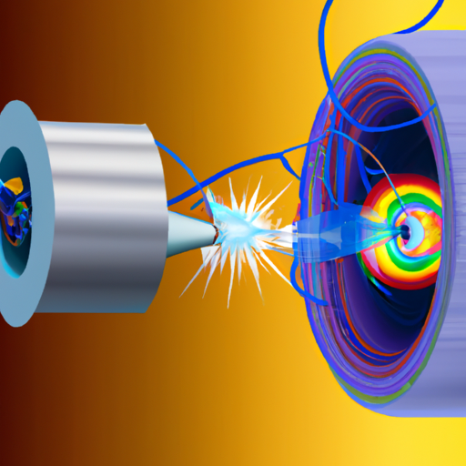

## Abstract:

This research proposal aims to combine the fields of quantum photonic devices and cryogenic electron microscopy (cryo-EM) for the structural and biophysical characterization of DNA-protein complexes. By utilizing the favorable optical and spin qualities of hexagonal boron nitride, we aim to establish the limits of performance for potential applications in quantum photonic devices, thereby contributing towards energy-efficient hardware for the upcoming quantum technological revolution. Additionally, we will utilize cryo-EM and single molecule optical tweezers for the structural characterization of DNA-protein complexes involved in gene expression regulation.

## Introduction:

Solid-state single photon generation platforms, such as diamond nitrogen-vacancy centers, currently require cryogenic cooling for coherent emission to be utilized in quantum devices. However, the scalability of these systems for industrial quantum technologies would demand enormous energy inputs for maintaining cooling. Therefore, there is a need to explore alternative material platforms that exhibit favorable optical and spin qualities at room temperature. Hexagonal boron nitride has shown promise in this regard, potentially leading to more energy-efficient hardware for quantum technological applications, particularly in the field of quantum photonic devices.

Moreover, the structural and biophysical characterization of DNA-protein complexes is crucial for understanding the underlying mechanisms of various biological processes, such as DNA transcription and mRNA translation involved in gene expression regulation. This characterization can be achieved through techniques such as cryo-EM and single molecule optical tweezers. Cryo-EM allows for high-resolution imaging of biomolecular structures in their natural state, while single molecule optical tweezers enable the manipulation and analysis of individual biomolecules.

## Methods:

To investigate the optical coherence properties of defects in hexagonal boron nitride, experiments will be conducted using quantum emitters and quantum communication techniques. Confocal microscopy will be employed to analyze the optical coherence properties of defects in the material. The characterization will involve measuring properties such as coherence time, photon statistics, and quantum yield. By comparing these results with existing leading material platforms, we can establish the potential for hexagonal boron nitride as a more energy-efficient alternative for quantum photonic devices.

Simultaneously, cryo-EM will be utilized to structurally characterize DNA-protein complexes. Sample preparation will involve isolating DNA-protein complexes and vitrifying them in a thin layer of vitreous ice. Three-dimensional reconstructions will be obtained through image processing and subsequent analysis, allowing for visualization and characterization of the protein-DNA interactions. Single molecule optical tweezers will be employed to manipulate and probe individual DNA-protein complexes, providing insights into the biophysical properties of these interactions.

## Expected Results:

The research is expected to demonstrate the potential of hexagonal boron nitride as a more energy-efficient material platform for quantum photonic devices. By establishing the limits of its performance through optical coherence properties analysis, we can lay the foundation for further developments in quantum technology. Additionally, the structural and biophysical characterization of DNA-protein complexes using cryo-EM and single molecule optical tweezers will provide valuable insights into the underlying mechanisms of gene expression regulation.

## Sustainable Impact:

The utilization of hexagonal boron nitride as an energy-efficient material platform for quantum photonic devices has the potential to significantly reduce energy consumption in future quantum technologies. By eliminating the need for cryogenic cooling, the scalability and practicality of such devices can be greatly enhanced. Furthermore, the structural and biophysical characterization of DNA-protein complexes will deepen the understanding of gene expression regulation, contributing to advancements in fields such as medicine and biotechnology.

## Conclusion:

This research proposal aims to combine the fields of quantum photonic devices and cryo-EM for the development of energy-efficient quantum hardware and the structural characterization of DNA-protein complexes involved in gene expression regulation. By exploring the optical coherence properties of defects in hexagonal boron nitride and utilizing cryo-EM and single molecule optical tweezers, this research has the potential to make significant contributions to both the field of quantum technology and molecular biology.